**Vascular Network Analysis User’s Manual**

John Peters 09/05/2018, Sara McBride-Gagyi 10/4/2018

1. **Set Up (Only needed once)**
2. Download Vascular Network Analysis MatLab Files and modified Fiji plug-in
3. Download Fiji (ImageJ extension)
4. Copy *AnalyzeSkeleton_-3.1.4-SNAPSHOT.jar* and paste it into Fiji’s plugin directory. This is most likely *C:\Users\*your user account here*\Fiji\fiji-win64\Fiji.app\plugins*. Delete the existing skeleton plugin.
5. **Running the Vascular Network Analysis (VNA) Protocol**
6. Export the general area of interest from the uCT scans as DICOMs
   1. Open the Scan
   2. Press the ‘T…’ button or navigate to Evaluation>3D Evaluation
   3. Select script file #8:Create Dicoms
   4. Alter the VOI until the area of interest is selected
   5. Press ‘Evaluate Script’
7. Use FileZilla (separate protocol) or other FTP software to copy the dicoms to your local server.
8. Make the data binary
9. Open Fiji
10. Open the scans by going to *File🡪Import🡪Image Sequence…*
11. Select the first image (DICOM) in the data set.
12. Convert the data to 8 bit grayscale by selecting the settings shown below.

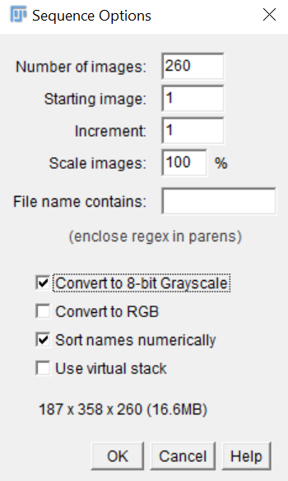

1. Click OK.
2. The data should display as a sequence.
3. Crop out any area that you do not want analyzed using the selection tools and Edit>clear or Edit>clear outside.
4. Threshold the data by going to *Image🡪Adjust🡪Threshold…*
   1. Use the sliders to eliminate as much noise as possible without removing too much of the vessels.

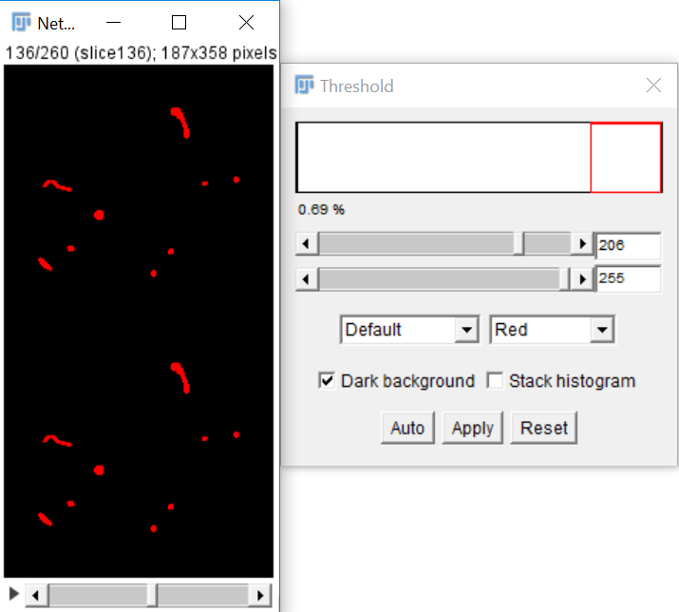

* 1. Click Apply,.
  2. On the next window, change the settings to the following (probably just deselect “Calculate threshold for each image”) and press ‘OK’

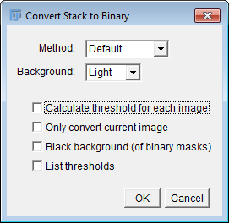

* 1. The result should look like the following – vessels as black and background as white. :

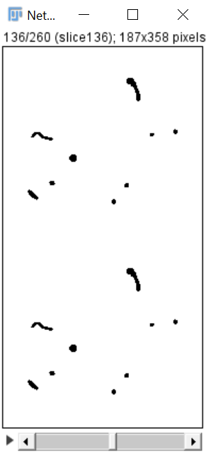

1. Save the thresholded data in the directory of your choice by going to *File🡪Save as🡪Image Sequence*..
2. Skeletonize the thresholded data
3. Go to *Plugins🡪Skeleton🡪Skeletonize (2D/3D)*
4. The result should look like the following

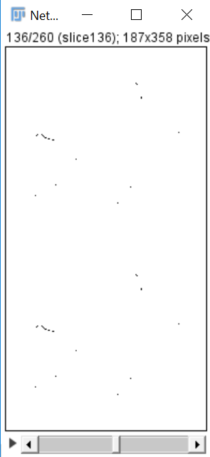

1. Analyze the skeleton
2. Go to *Analyze🡪Skeleton🡪Analyze Skeleton (2D/3D)*
3. Make sure the options are selected as follows
4. 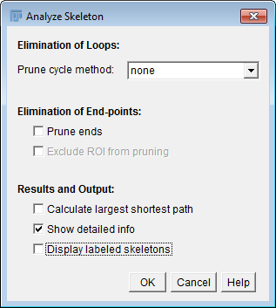
5. 2 windows should appear. Save each window as a .csv file by going to *File🡪Save as…*
6. Exit out of Fiji, but DO NOT save the image stack. It is now skeletonized, and you will need the non-skeletonized, but thresholded, image stack for the next module.
7. Vascular Analysis
8. Open Vascular Network Analysis .m file (MATLAB Code) in MATLAB.
9. Hit ‘Run’ to get the GUI to open. Change folders if necessary.
10. Click *Browse* next to the label *Branch* Information. Input the *Branch Information* file (.csv) by navigating to it in the directory and clicking open.
11. Click *Browse* next to the label *Upload Raw Data*. Navigate to the location where you saved the thresholded image sequence in II.B).
12. Click the first image in the sequence and click open.
13. Check the value in the *Resolution (mm/voxel)* box. If this is incorrect, manually set it to the correct value.
14. Click *Run*.

NOTE WELL: If the data set is large (many slices in the z direction), check the *Accelerate Distance Transform* box BEFORE clicking run. This speeds up a lengthy computation with very minimal changes in accuracy.

1. After the program is finished processing, the results box will populate (Figure 5). You can toggle between mm and voxels by checking and unchecking the *mm/voxel* box. Histograms of the diameters and individual vessel lengths can be seen in the *Histogram* box. If the histogram is set to “manual”, it will require that you set a nonzero value for the *Number of Bins:* box. Data can be viewed and exported in the *View/Export* box.

NOTE WELL: *Histogram* and *View* buttons **WILL NOT WORK** in MATLAB 2013. Please upgrade the MATLAB license to 2016 or above.

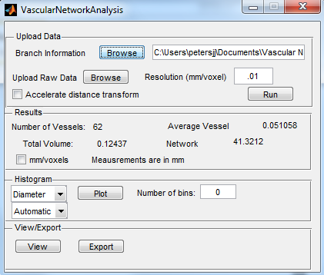

**.**

Any questions can be directed to: John Peters (630) 251-9363